DEPARTMENT OF INFORMATION SCIENCE AND ENGINEERING
CINEBOOK: AN ONLINE MOVIE
TICKET BOOKING SYSTEM

Data Structures and Applications – IS233AI
Experiential Learning (Lab)
REPORT

Submitted by
G. SAI ROOPA SREE [1RV24IS041]
DEVISRI HARSHINI BARMAL [1RV24IS032]
Under the guidance of
B K Srinivas
Assistant Professor,
Department Of Information Science

In partial fulfilment for the award of degree of
Bachelor of Engineering
in
Department of Information Science and Engineering
2025-2026



CERTIFICATE

Certified that the project work titled ‘CineBook: An Online Movie Ticket Booking Sytem’ is carried out by G. Sai Roopa Sree(1RV24IS041), Devisri Harshini Baramal (1RV24IS032) who are bonafide students of RV College of Engineering, Bengaluru, in partial fulfilment for the award of degree of Bachelor of Engineering in Information Science and Engineering of the Visvesvaraya Technological University, Belagavi during the academic year 2025-2026. It is certified that all corrections/suggestions indicated for the Internal Assessment have been incorporated in the report deposited in the departmental library. The report has been approved as it satisfies the academic requirements in respect of experiential learning work prescribed by the institution for the said degree.

Signature of Guide Signature of Head of the Department
B K Srinivas Dr. G S Mamatha

External Viva
Name of Examiners Signature with Date
1
2



DECLARATION

We, G. Sai Roopa Sree, Devisri Harshini Baramal students of Third semester B.E., department of Information Science Engineering, RV College of Engineering, Bengaluru, hereby declare that Experiential Learning (Lab) titled ‘CineBook: An Online Movie Ticket Booking System’ has been carried out by us and submitted in partial fulfilment for the award of degree of Bachelor of Engineering in Information Science and Engineering during the academic year 2025-26

We also declare that any Intellectual Property Rights generated out of this project carried out at RVCE will be the property of RV College of Engineering®, Bengaluru and we will be one of the authors of the same.
[
Place: Bengaluru

Date:

Name Signature

1. G. SAI ROOPA SREE [1RV24IS041]

2. DEVISRI HARSHINI BARAMAL [1RV24IS032]

Abstract

The growing popularity of online entertainment has made it necessary to create better and smarter movie ticket booking systems. Traditional ways of booking tickets and many online platforms usually require users to manually choose seats and enter basic information, which leads to a poor user experience and inefficient use of resources. To solve these issues, we introduce CineBook, an online movie ticketing system that uses Data Structures and Algorithms to improve movie search, automate seat allocation, and manage bookings. The main goal of this project is to build a reliable and easy-to-use system that shows how DSA concepts can be applied in real-life situations.
CineBook is a web application that runs on the client side and is built using HTML, CSS, and JavaScript. The browser's local storage is used to save booking and seat details. Movie data is stored in a Binary Search Tree (BST) so that searching and organizing movies is faster and more organized. Theatre seat arrangements are shown using two-dimensional arrays to accurately show which seats are available. A Priority Queue, which is built using a Max Heap, is used to suggest the best seats to users based on set rules like where the seats are located and how good the viewing position is. The current software does not need any special hardware to work.
The results show that the new system works better than old methods like simple searching and manual seating. It makes it easier and faster to find seats. The priority system helps users choose seats with less effort and makes the booking process more consistent. Using organized data storage stops people from booking the same seat twice, which keeps the system running smoothly.
Overall, the CineBook system shows how using smart algorithms can improve online ticket booking apps a lot. This project proves how important data structures are in solving real-life problems and sets the stage for adding more features like supporting multiple users, connecting to a backend, making payments safe, and suggesting seats to users.

Table of Contents
Page No

Abstract 4

Chapter 1: Introduction 6

Chapter 2: Solution Design 7

Chapter 3: Implementation Details. 9

Chapter 4: Results and Discussion 10

Chapter 5: Conclusion and Future Scope 15

References 16

Chapter 1: Introduction

1.1 Overview
Rapid digitalization of services has made online movie ticket booking a popular choice among customers, thus going to the counter of a traditional theatre is becoming an obsolete option. Usually, people have to face long queues, pick seats manually, and generally waste their time with traditional methods. Even as some existing online platforms provide basic booking services, they still lack smart seat selection and do not efficiently handle data. Therefore, this project is about designing a deeply structured online movie ticketing system that improves search efficiency, seat management, and user experience by utilizing Data Structures and Algorithms.
1.2 Significance of the Project
An online ticketing system is required to handle a huge volume of data such as movies, theatres, schedules, and seat availability. If proper data structures are not used, then these operations can become very slow and prone to errors. As a result, by using the right DSA concepts, the designed system will be able to provide quicker searching, efficient seat allocation, and booking management that is consistent. This endeavour, in addition, is an academic exemplar presenting data structures as a viable solution to real, world problems.
1.3 Objectives of the Project
The main objectives of the proposed system are:
- To design an online movie ticket booking system with efficient movie search and seat management.
- To implement priority‑based seat allocation using suitable data structures.
- To demonstrate the real‑world application of Data Structures and Algorithms such as Binary Search Trees, Priority Queues, and two‑dimensional arrays.

Chapter 2: Solution Design

2.1 System Design
The proposed system, CineBook, is a straightforward clientside architecture aimed at delivering an efficient movie ticket booking experience with intelligent seat selection. The system is realized as a web based application through which the user interacts with the interface via a browser. The front end is responsible for movie browsing, theatre selection, seat selection, and booking confirmation. All processing logic, including search operations and seat prioritization, is carried out with JavaScript. The information concerning movies, seat availability, and bookings is kept through browser local storage to allow for persistence across sessions. Such an architecture does away with the necessity of external servers and thus offers a lightweight yet efficient solution.

2.2 Selection and Justification of Data Structures Used
Appropriate data structures are selected to improve system efficiency and reliability. A Binary Search Tree (BST) is used to store movie details, enabling faster searching and ordered traversal compared to linear search methods. Two‑dimensional arrays are used to represent theatre seating layouts, where each element indicates whether a seat is available or booked, ensuring accurate seat management. A Priority Queue implemented using a Max Heap is used for best seat recommendation by assigning higher priority to seats with better viewing positions. Hash maps are used to store booking details using unique booking IDs as keys, allowing quick access and cancellation. These data structures collectively enhance performance, prevent seat duplication, and reduce user effort.

2.3 Flowchart
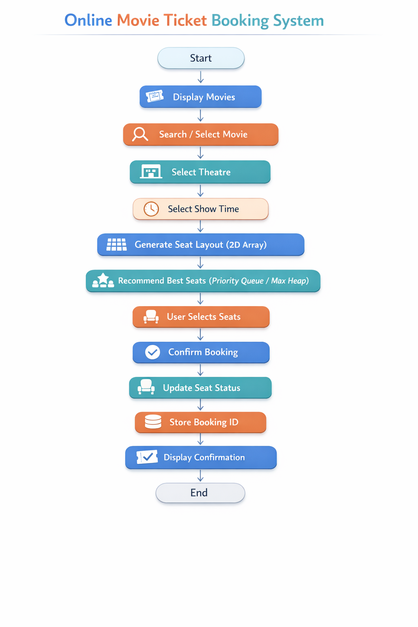

Chapter 3: Implementation Detail
3.1 Implementation Approach
The proposed online movie ticketing system, CineBook, is implemented as a client‑side web application using HTML, CSS, and JavaScript. The application follows a modular and structured approach where the user interface, data handling, and algorithmic logic are clearly separated. The system allows users to browse movies, select theatres and show timings, choose seats, and confirm bookings through an interactive interface. All processing, including movie searching, seat prioritization, and booking management, is handled within the application logic, ensuring fast response and smooth user interaction.
Core Data Structures and Algorithms are integrated into the implementation to improve system efficiency. A Binary Search Tree (BST) is used to organize movie data and enable faster searching. Theatre seating layouts are implemented using two‑dimensional arrays to accurately track seat availability. A Priority Queue implemented using a Max Heap is used to recommend the best available seats based on predefined priority criteria. Booking details are stored using key‑value mappings to allow quick access and easy cancellation.
3.2 Coding Best Practices
Many coding best practices have been implemented to guarantee the system's readability, modularity, and maintainability. The code is logically segregated into different modules such as movie management, seat handling, booking operations, and user interface control.
Clarity and comprehension are enhanced by the use of meaningful variable and function names. Reusable functions are created to eliminate redundancies and make the code easier to modify in the future. Comments are added to the important sections of the code to explain the logic and facilitate maintainability.
The local storage of the browser is utilized to keep the data persistently without the need for external databases. The overall design of the system is such that it is very easy to extend, debug, and enhance, thus enabling the addition of features like backend integration or multiuser support in the future.

Chapter 4: Results and Discussion
4.1 Execution Outcomes and Algorithm Validation
CineBook was staged and flighted with a variety of booking scenarios. No one encountered errors throughout the journey from movie browsing to user, initiated booking completion: the searching by title, the selecting theatres and show timings, the choosing of seats, and the finalizing of bookings. All algorithm implementations were checked for correctness through testing again and again. Using the Binary Search Tree (BST) for movie search delivered the accurate and sorted results, whereas two-dimensional arrays were responsible for the correct management of seat availability. The Priority Queue based on a Max Heap at all times showed the best seats available thus verifying the correctness of the seat prioritization algorithm.
4.2 Handling of Special and Edge Cases
The system is proficient in dealing with most edge cases that are typical of such situations and can be trusted in terms of stability. It is restricted to select a seat that is already taken, and users are not allowed to book more seats than the ones that are available. Invalid movie searches and incorrect booking IDs are simple and easy to understand errors for the user, while the system remains stable. The statuses of seats are changed at the very moment of booking or cancellation, thus the system prevents the double bookings and retains the data consistency
4.3 Comparative Assessment of Algorithms
The algorithms implemented were benchmarked against simpler alternatives. Movie searching based on BST was significantly more efficient than linear search, particularly when the number of movies was large. Seat selection based on Priority Queue offered the best viewing conditions as compared to random or manual seat selection. Two, dimensional arrays for seat layout management gave more transparency and control as compared to one, dimensional approaches.

4.4 Simulation Results and Screenshots
- Home page
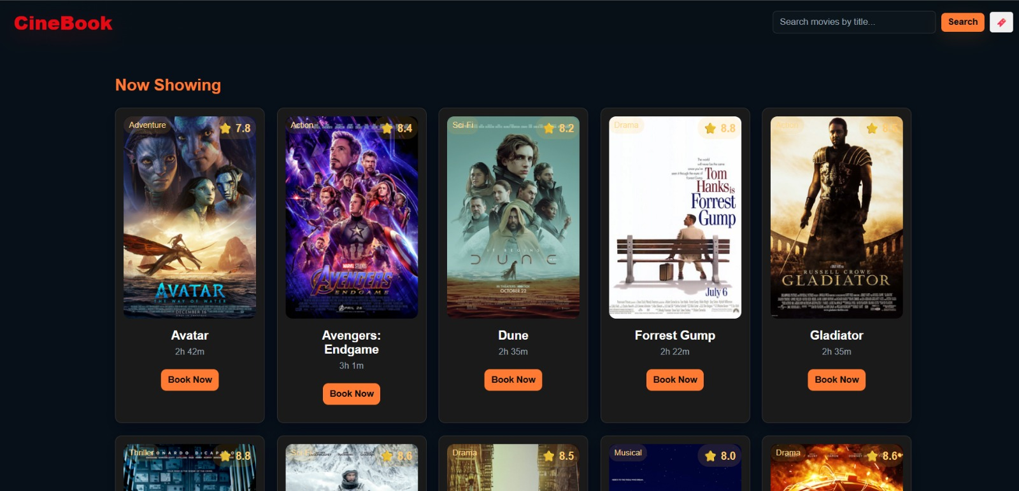
- Movie search result
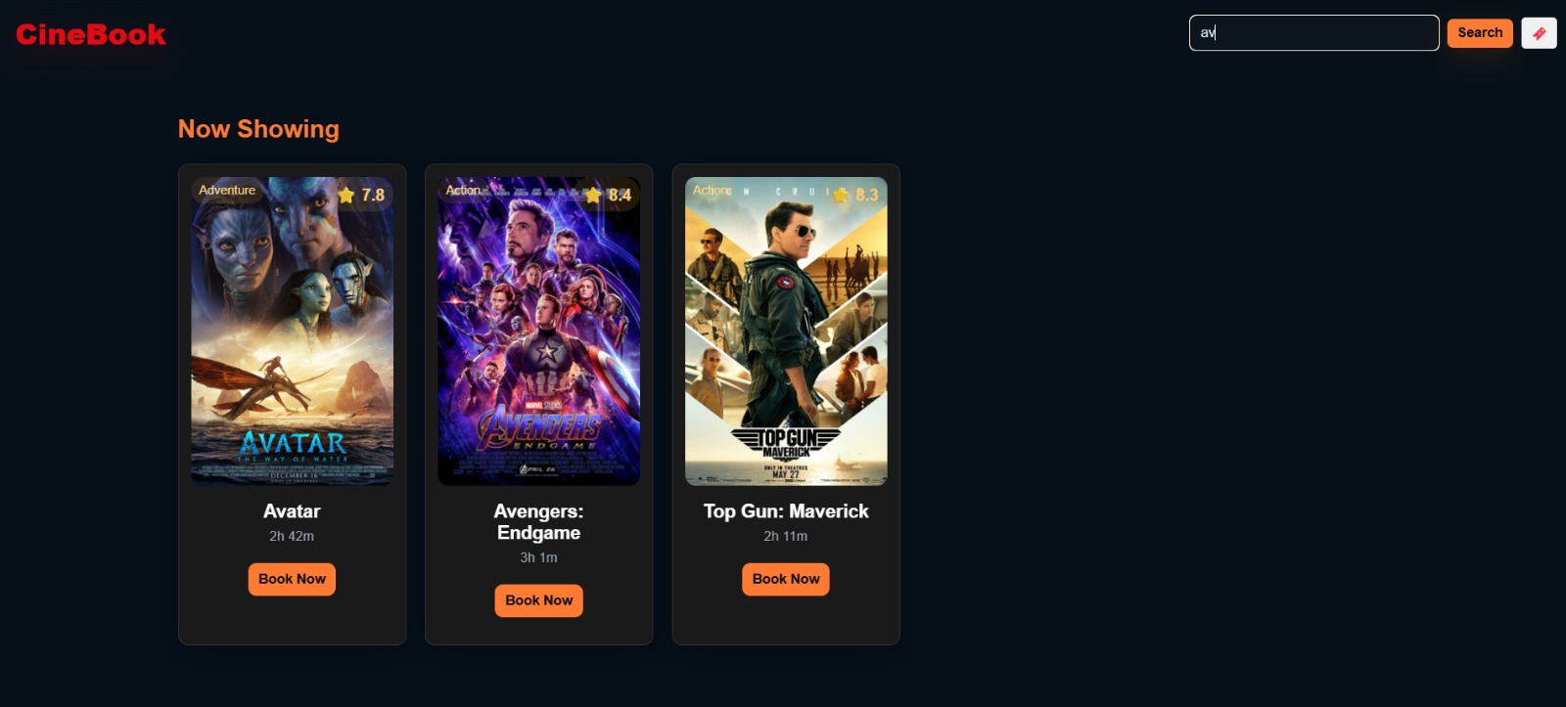

- Theatre
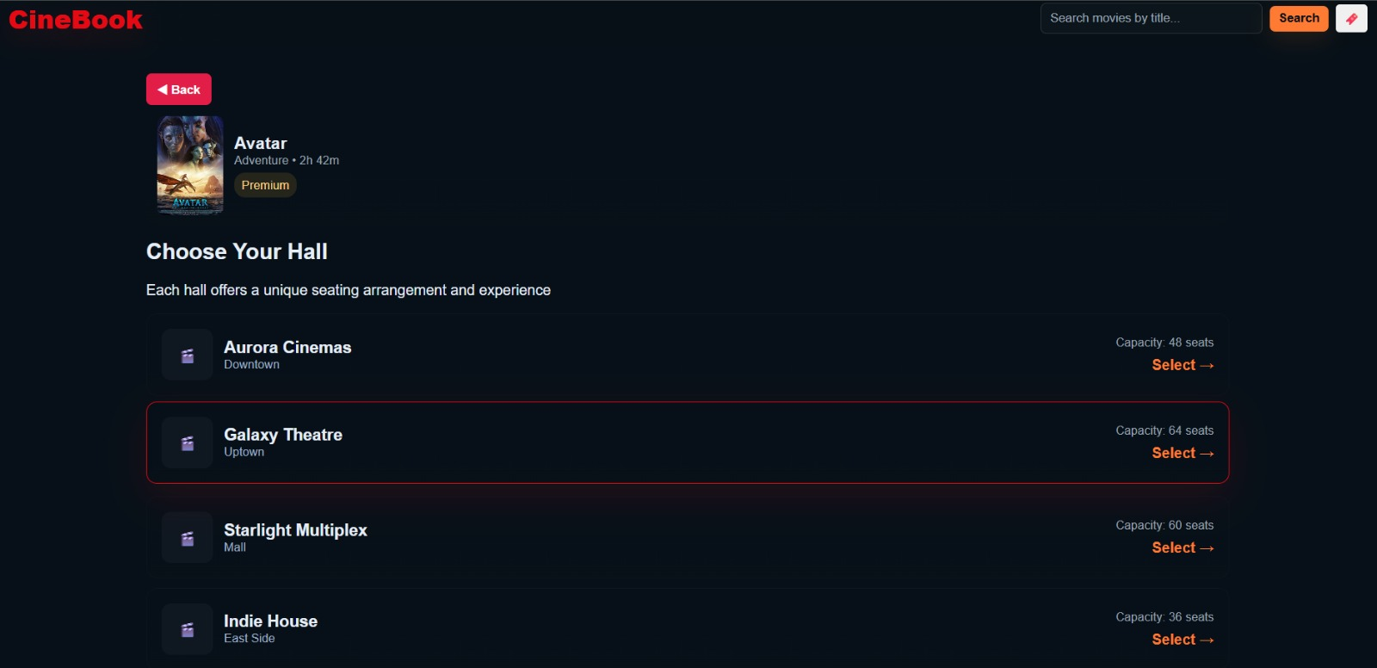
- Time slot selection page
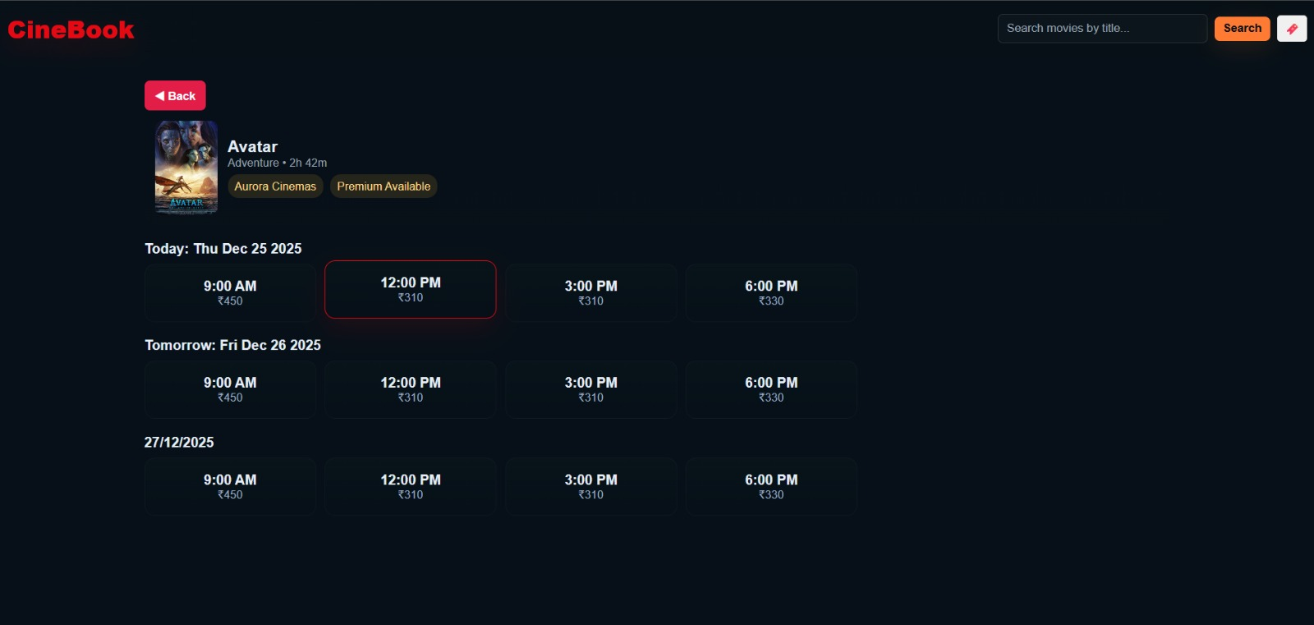
- Seat layout page
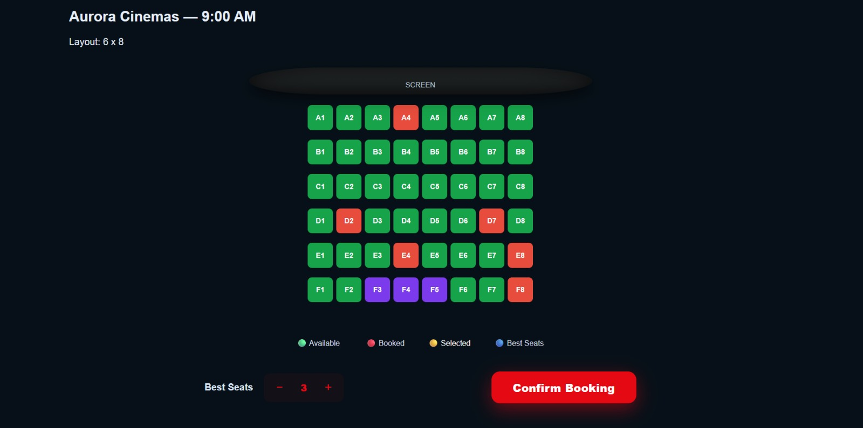
- Booking confirmation page
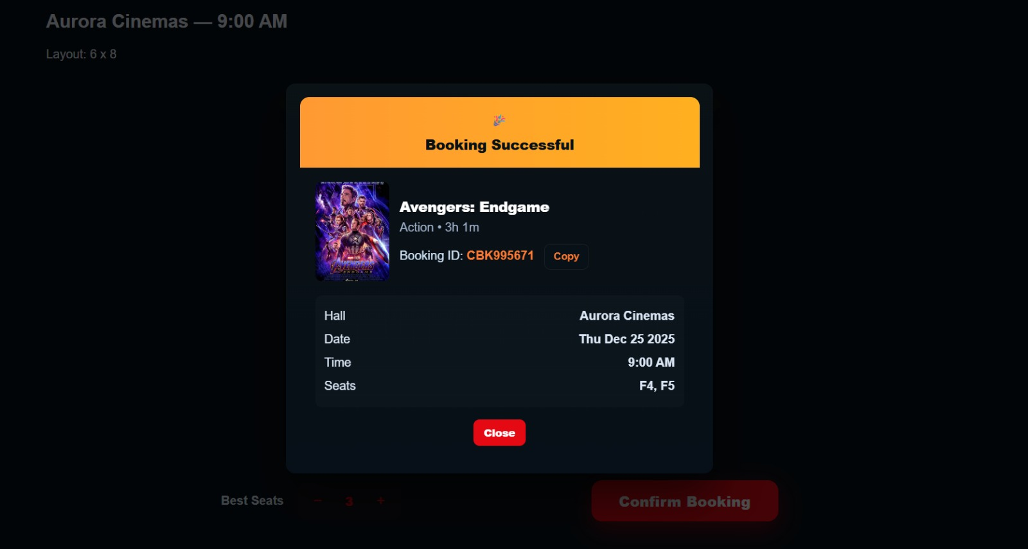
- Ticket details page
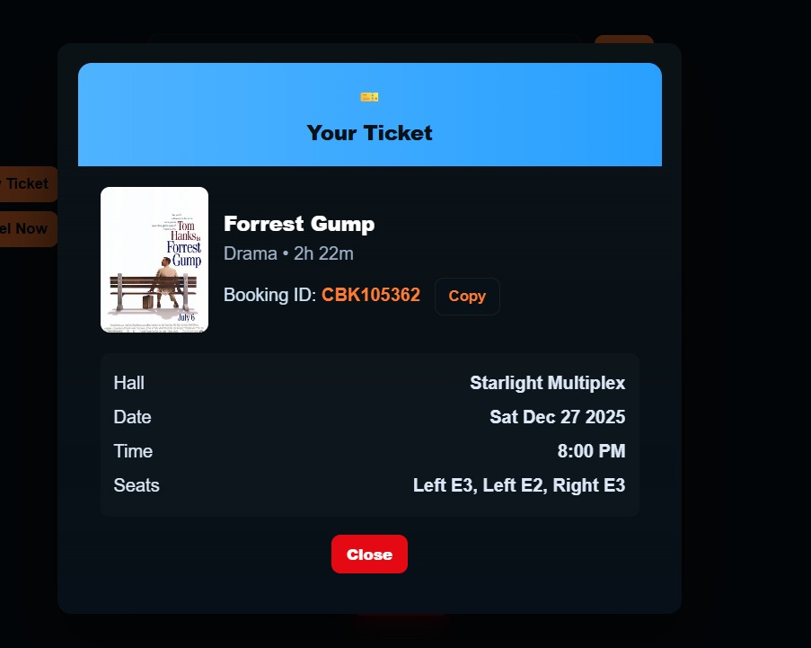
- Cancellation confirmation page
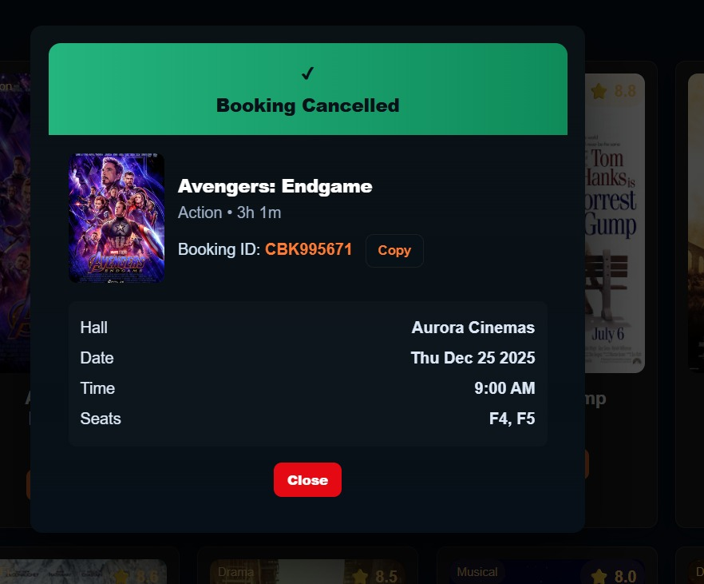
- Booking Status page
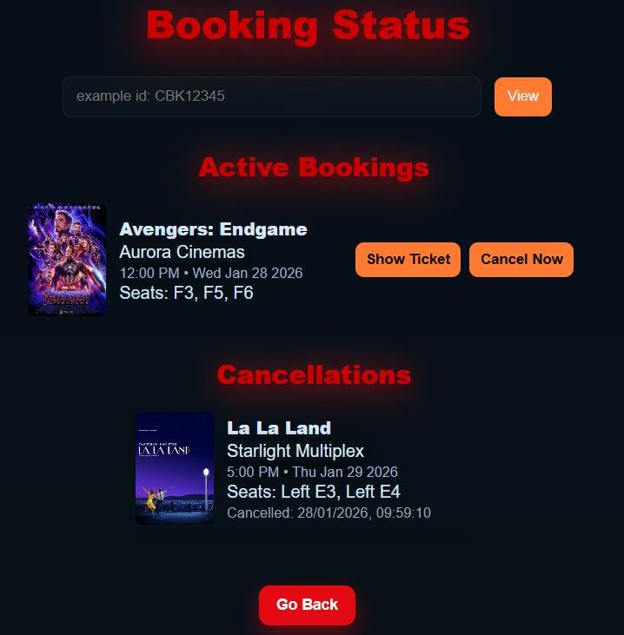
4.5 Discussion and Possible Improvements
While the system is performing efficiently in its present state, there are still some possibilities for further enhancements. The system may be equipped with backend and database support to cater to multiple users at the same time. Some of the additional advancements may be a secure online payment integration, dynamic pricing, and personalized movie recommendations. In addition, by refining the seat prioritization logic and upgrading the user interface, the user experience can be improved even more.

Chapter 5: Conclusion and Future Scope

5.1 Conclusion
This project successfully designed and implemented CineBook, an online movie ticketing system that demonstrates the effective application of Data Structures and Algorithms in a real-world scenario. Efficient movie searches, well-organized seat handling, and smart seat picking are some of the features of the system that uses a Binary Search Tree, two-dimensional arrays, and a Priority Queue implemented using a Max Heap. The correctness and the reliability of the algorithms implemented have been confirmed by the results obtained during the simulation. Therefore, the system enhances the user experience by saving users from manual work, avoiding booking conflicts, and enabling optimal seat allocation.
5.2 Real‑World Applicability
Moreover, the proposed system is a close match to the real-world cinema ticketing platforms. Due to its modular and algorithm-driven design, it is capable of handling movie listings, seat availability, bookings, and cancellations. The priority-based seat recommendation feature enhances the user's comfort and is a good reflection of the practical requirements of the industry thus making the project both academically and practically relevant.
5.3 Additional Innovation and Future Scope
Later on, the device can be upgraded by adding a backend server and a database to allow multiple users to be connected at the same time. Besides that, features such as secure online payment gateways, dynamic pricing, personalized movie recommendations, and mobile application support can be introduced to enhance scalability and remain attractive to the industry. By adding these features, the system can become a fully operational commercial grade application.

References
- T. H. Cormen, C. E. Leiserson, R. L. Rivest, and C. Stein, Introduction to Algorithms, 3rd ed. Cambridge, MA, USA: MIT Press, 2009.[Online]. Available: https://mitpress.mit.edu/9780262033848/

- M. A. Weiss, Data Structures and Algorithm Analysis, 3rd ed. Boston, MA, USA: Pearson Education, 2012. [Online]. Available: https://www.pearson.com/en-us/subject-catalog/p/data-structures-and-algorithm-analysis/P200000003295

- D. Flanagan, JavaScript: The Definitive Guide, 7th ed. Sebastopol, CA, USA: O’Reilly Media, 2020. [Online]. Available: https://www.oreilly.com/library/view/javascript-the-definitive/9781491952016/

- S. K. Sharma and R. Singh, “Design and Implementation of an Online Movie Ticket Booking System,” International Journal of Computer Applications, vol. 113, no. 6, pp. 1–5, 2015. [Online]. Available: https://www.ijcaonline.org/archives/volume113/number6/

- A. Kumar and P. Verma, “Efficient Seat Allocation Algorithm for Online Reservation Systems,” International Journal of Advanced Research in Computer Science, vol. 8, no. 5, pp. 234–238, 2017. [Online]. Available: https://ijarcs.info/index.php/Ijarcs

- P. Patel and N. Shah, “Application of Data Structures in Real-Time Online Systems,” International Journal of Engineering Research and Technology (IJERT), vol. 6, no. 4, pp. 412–416, 2017. [Online]. Available: https://www.ijert.org/

